Director Gary C. Mohr
Ohio Department of Rehabilitation and Correction
770 W. Broad St.
Columbus, OH 43222

Director Mohr,

We continue to be troubled by the litany of unsafe and irresponsible activities of Aramark and its employees in Ohio prisons. Since September 2013, Aramark has proved to be an incompetent provider.

Over 100 Aramark employees have been banned from Ohio prisons for illegal or inappropriate behavior, and the state has levied a total of $272,000 in fines against them for contract violations, including sexual relationships between employees and inmates, widespread food contamination, insufficient meal preparation and understaffing. It is disturbing to know that a portion of these funds will be used to provide additional training to Aramark employees. This—along with reports of corrections staff leaving their posts to help out in the kitchens—amounts to subsidizing Aramark’s contract for services with additional taxpayer resources.

The state should contract for services with businesses that are able and ready to meet the public’s expectations. We should not be in the business of remediation for bad actors.

We recognize you have claimed responsibility for Aramark’s shortcomings, and in what seems like a last ditch effort, DRC is increasing training, changing meal plans and increasing county health inspections. These are laudable efforts, but it is becoming obvious that the state simply cannot trust Aramark to fulfill its contractual obligations. How many times will DRC bail out Aramark, and at what cost?

As specified in DRC’s contract with Aramark, there must be a 90-day notice prior to contract termination. With this clause in mind, we implore DRC to terminate its relationship with Aramark as soon as possible. We must start off 2015 on the right foot by returning the prisons’ operations back to the state and to our capable, skilled public employees.

We thank you in advance for your timely response to this urgent request.

Sincerely,
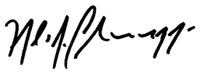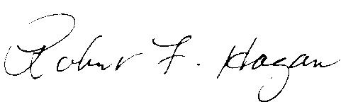
Matt Lundy Nicholas Celebrezze Robert F. Hagan
State Representative State Representative State Representative
55th House District 15th House District 58th House District
Ohio House of Representatives Ohio House of Representatives Ohio House of Representatives

